Project Design Phase-II

Data Flow Diagram & User Stories

|  |  |
| --- | --- |
| Team ID | PNT2022TMID17612 |
| Project Name | Smart Fashion Recommender Application |

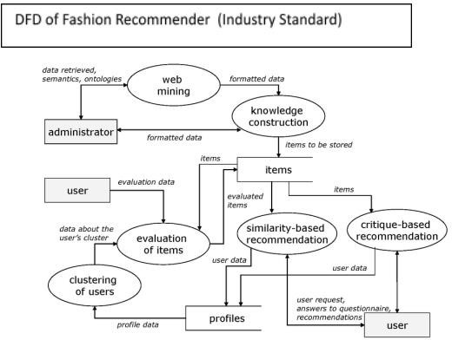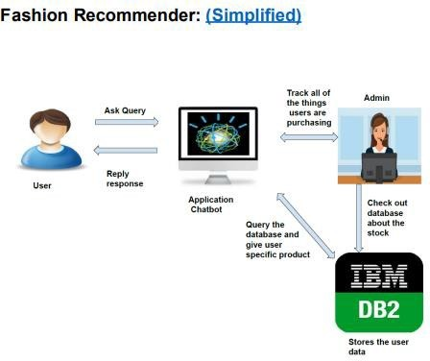

User Stories

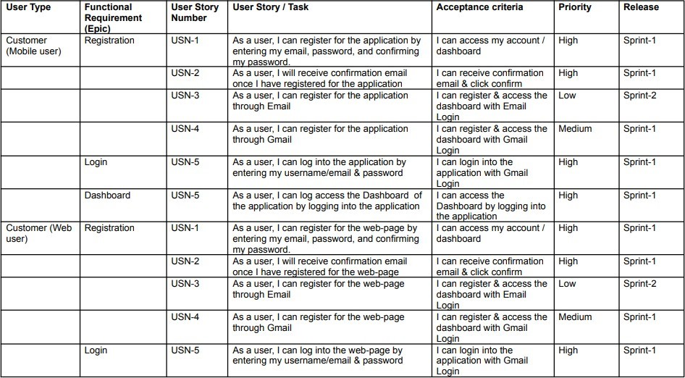

|  |  |  |  |  |  |  |
| --- | --- | --- | --- | --- | --- | --- |
| User Type | Functional  Requi11ement  (Epic) | User Story  Number | User Story *l* Task | Acceptance c,riteria | Priority | Release |
|  | Dashboard | USN-5 | As a user, I can log aooess the !Dashboard by logging into the web-page | IIcan access the  Dashboard by logging into the web-paqe. | IHigh | Sprint-1 |
| Customer Care Executive | Login | USN-1 | As a Customer Care IE ecutive, IIcan ll og into he application by entering1my Executive email id & oassword | IIcan login into the application with Gmail Loain | IHigh | Sprint-1 |
|  | Dashboard | USN-1 | As a Customer Care IE ecutive, IIcan access U'1e Dash'board of the application by logging into the annlication | IIcan access the  Das'ilboard by logging into the annlication | IHigh | Sprint-1 |
|  | Service | USN-1 | As a Customer Care IE ecutive, IIcan access he Customer service page of the applllication by logging and acoessing the pag:e | IIcan access the Service pageby logging1& acoessing the pag:e |  | Sprint-1 |
| Administrator | Login | USN-1 | As a Administrator, I can log into the  app:llication by entering my Administer emaill id & cassword | IIcan login into th,e application with Gmail Loqin |  | Sprint-1 |
|  | Dashboard | USN-1 | As a Administrator, I can acoess the  Das'ilboard of the application by logging1into he annlication | IIcan access the  Das'ilboard by logging into the annlication | IHigh | Sprint-1 |
|  | Administration & Service | USN-1 | As administrator, I can aocess Administration & service page of the application by logging1& acoessing the page | IIcan access the  Administration & Service page lby log:ging and acoessinc the JJ _ac:e |  | =- |